

|  |  |
| --- | --- |
| Project | Computer Shop Management System |
| Prepared By | B.G.L.Madushan |
| Register No | 18SSL5345 |
| University | Sabaragamuwa University of Sri Lanka |
| Faculty | Social Sciences & Languages |
| Subject | ICT222(3) Application of System Design – Project Work |
| Year | Year II Semester II |
| Lecture | Mr. Rumesh Weerakoon |
| Document | PDF – BRD/FRD |
| Date | 2022/06/07 |

1. Scope of the Object

Computer (Desktop, Machine, Laptop, Tabs, etc.) and devices (keyboard, mouse, printer, etc.) related information, information on computer and devices sold, and stock easily to know and also efficient work in shop, save time and providing quality service.

1. Business Problems

This shop note down all about computer and devices details in some book. It is a difficult way. Some details are missing and destruction.

1. Proposed Solutions

I want to introduce database software for give better experiences and service to shop and customer.

1. Impacted Systems

Using a VB.net to create database for computer shop.

1. Business Requirement
2. Profile management

* Ability to login for admin
* Ability to change password
* Ability to edit profile

1. Categories management

* Ability to add new details (computer)
* Ability to edit

1. Stock management

* Ability to add new details
* Ability to edit

1. Sell management

* Ability to add sell product
* Ability to edit

**FRD**

1. **Profile management**
   1. Ability to login
   2. Display home page

Login button, logout button display menu bar and other tabs (categories, stock, sell).

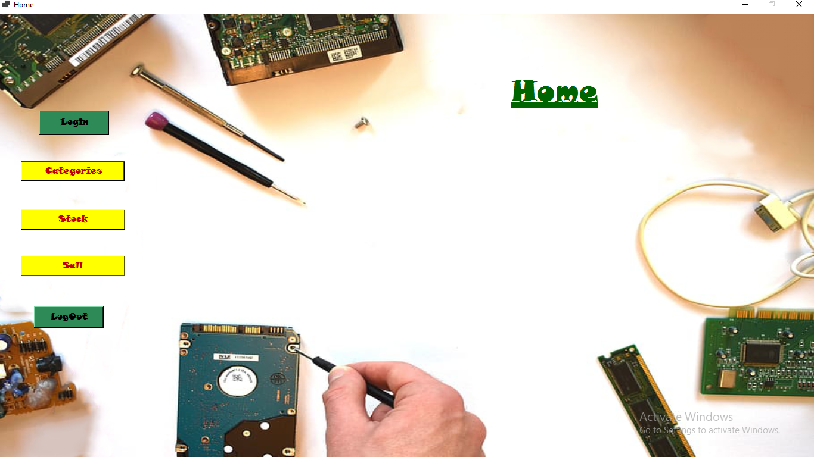

|  |  |  |  |  |  |  |
| --- | --- | --- | --- | --- | --- | --- |
| **Field Name** | **Field Type** | **Content** | **Required Field** | **Min Character** | **Max Character** | **Note** |
| Login | Command Button | N/A | N/A | N/A | N/A | If click button open login window |
| Logout | Command Button | N/A | N/A | N/A | N/A | If click button logout window |
| Categories | Command Button | N/A | N/A | N/A | N/A | If click open categories window |
| Stock | Command Button | N/A | N/A | N/A | N/A | . If click open stock window |
| Sell | Command Button | N/A | N/A | N/A | N/A | If click open sell window |

* 1. Navigation of login button

When click on the login button, system should display window in the middle.

* 1. New window interface

System display following field.

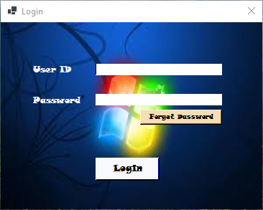

|  |  |  |  |  |  |  |
| --- | --- | --- | --- | --- | --- | --- |
| **Field Name** | **Field Type** | **Content** | **Required Field** | **Min Character** | **Max Character** | **Note** |
| User ID | Text Box | Text | Yes | 8 | 10 |  |
| Password | Text Box | N/A | Yes | N/A | N/A | Should encrypted |
| Forget Password | Hyperlink | N/A | N/A | N/A | N/A | On click |
| Login | Command Button | N/A | N/A | N/A | N/A | On click, if the validation passed can go to home page. |

1.4.1 Validation for user ID

If the user ID is invalid, display message “invalid user ID try again”. Valid a user ID when you enter correct password.

1.4.2 Validation for password

If the user ID is invalid, display message “Invalid password try again.”

1.4.3 Validation for failed attempts.

It the password failure count is more than 3. System should disable and display a massage that “Your database gas been locked”, contact the software owner.

1.4.4 Forget password

When you click forget button you go new window and can be change password, entering new password and old password.

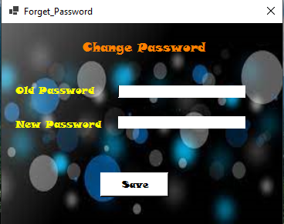

1. **Category management**

2.1 New computer, laptop and devices adding page fields.

System should display the following data fields on new item adding page interface.

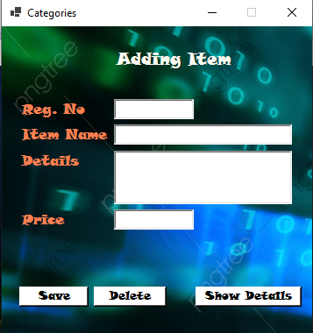

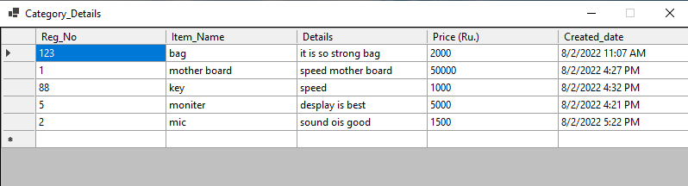

|  |  |  |  |  |  |  |
| --- | --- | --- | --- | --- | --- | --- |
| **Field Name** | **Field Type** | **Content** | **Required** | **Min Cha.** | **Max Cha.** | **Notes** |
| Reg.No | Table | Text | Yes | 4 | 8 | Type here |
| Item Name | Table | Text | Yes | 8 | 12 | - |
| Details | Table | Text | Yes | 10 | 20 | - |
| Price (Ru.) | Table | Currency | Yes | 5 | 8 | - |
| Created Date | Table | Date & Time | Yes | - | - | - |
| Delete | Command Button | N/A | N/A | N/A | N/A | Click on |
| Save | Command Button | N/A | N/A | N/A | N/A | Click on |
| Show Details | Command Button | N/A | N/A | N/A | N/A | - |

2.2 Click on delete button

When select the item can you delete data and finally you must click save button.

2.3 Click on save button

Entering new item details finally you must click on save button.

2.4 Searching item

You can search item using the search bar. There can type register number and item name. And show the item details.

1. **Stock management**

3.1 Current stock and new stock adding system should display the following data filed.

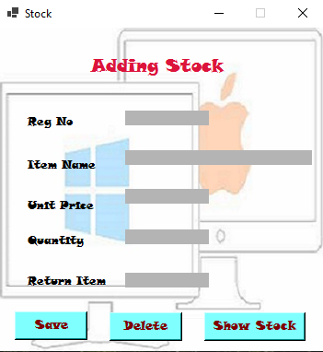

|  |  |  |  |  |  |  |
| --- | --- | --- | --- | --- | --- | --- |
| Field Name | Field Type | Content | Required | Min Cha. | Max Cha. | Notes |
| Reg.No | Table | Text | Yes | 4 | 8 | Type here |
| Item Name | Table | Text | Yes | 8 | 12 | - |
| Unit Price | Table | Currency | Yes | 8 | 12 | - |
| Quantity | Table | Number | Yes | 3 | 20 | - |
| Return Item | Table | Number | N/A | N/A | 8 | - |
| Delete | Command Button | N/A | N/A | N/A | N/A | Click on |
| Save | Command Button | N/A | N/A | N/A | N/A | Click on |
| Show Stock | Command Button | N/A | N/A | N/A | N/A | Click On |
| Created Date | Table | Date & Time | Yes | - | - | - |

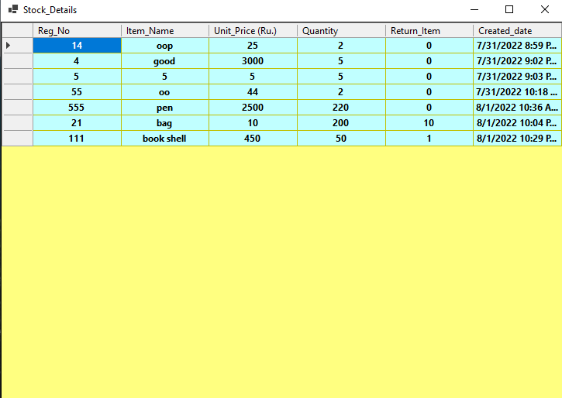

1. **Sell Management**

Current sell details adding to table, should display the following data filed.

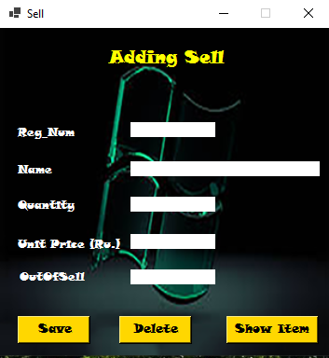

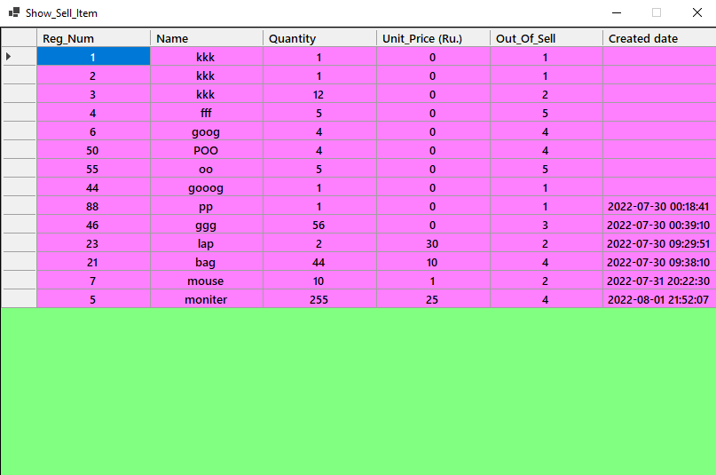

|  |  |  |  |  |  |  |
| --- | --- | --- | --- | --- | --- | --- |
| Field Name | Field Type | Content | Required | Min Cha. | Max Cha. | Notes |
| Reg. No | Table | Text | Yes | 4 | 8 | Type here |
| Item Name | Table | Text | Yes | 8 | 12 | - |
| Quantity | Table | Number | Yes | 3 | 20 | - |
| Unit Price (Ru.) | Table | Currency | Yes | 2 | 10 | - |
| Out of Sell | Table | Yes/No | N/A | N/A | 8 | - |
| Created Date | Table | Date & Time | Yes | - | - | = |
| Delete | Command Button | N/A | N/A | N/A | N/A | Click on |
| Save | Command Button | N/A | N/A | N/A | N/A | Click on |
| Show Item | Command Button | N/A | N/A | N/A | N/A | - |